1: Web API Hands-On
First Web API using ASP.NET Core

Objective
To create and execute a simple ASP.NET Core Web API with controller-based GET, POST, PUT, and DELETE action methods, and verify the GET response.

Steps Performed
1. Installed the .NET SDK and verified the installation using dotnet --version.
2. Created an ASP.NET Core Web API project named FirstWebApi using the controller template.
3. Created ValuesController.cs inside the Controllers folder.
4. Implemented GET, POST, PUT, and DELETE HTTP action methods.
5. Built the project using dotnet build.
6. Executed the application using dotnet run.
7. Tested the GET endpoint at /api/values and verified the returned JSON response.

ValuesController.cs
using Microsoft.AspNetCore.Mvc;
namespace FirstWebApi.Controllers
{
[ApiController]
[Route("api/[controller]")]
public class ValuesController : ControllerBase
{
[HttpGet]
public IActionResult Get()
{
string[] values = { "value1", "value2" };
return Ok(values);
}
[HttpGet("{id}")]
public IActionResult Get(int id)
{
return Ok($"Value with ID = {id}");
}
[HttpPost]
public IActionResult Post([FromBody] string value)
{
return Ok($"Added: {value}");
}
[HttpPut("{id}")]
public IActionResult Put(int id, [FromBody] string value)
{
return Ok($"Updated ID {id} with {value}");
}
[HttpDelete("{id}")]
public IActionResult Delete(int id)
{
return Ok($"Deleted ID = {id}");
}
}
}

Output
GET endpoint:
http://localhost:5133/api/values
Returned JSON response:
["value1", "value2"]
Execution screenshot:
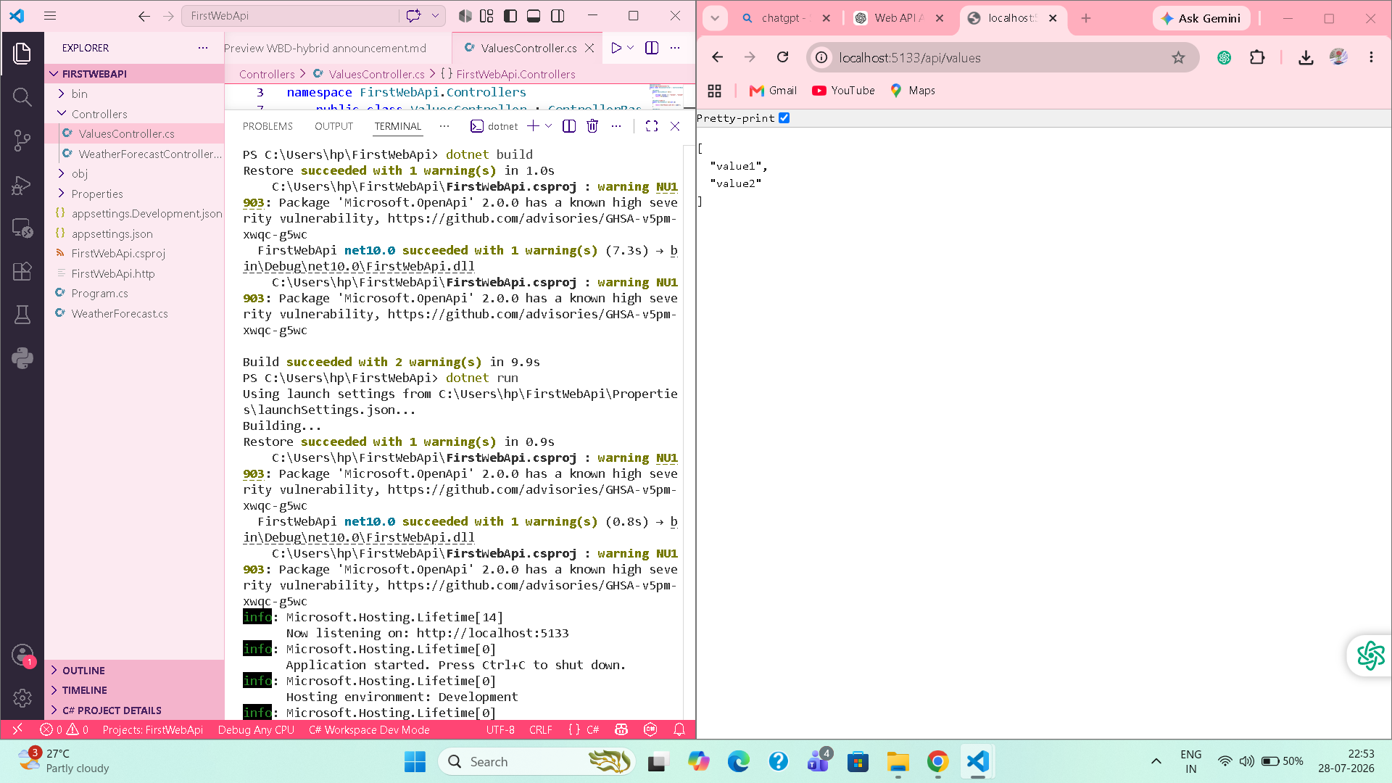

Result
The ASP.NET Core Web API was created and executed successfully. The GET action method returned the expected values, confirming that the Web API is working correctly.

